**LAB MANUAL**

**of Subject**

**ESSENTIAL SKILLS OF INFORMATION TECHNOLOGY**

**Subject Code: 09CT0101**

**Student Name: Meet Butani**

**Enrollment No:** 91900957044

**Submission Date: 26/11/2019**

**Department of Information & Communication Technology**

**Student of Diploma Engineering**



**ESIT LAB - PRACTICAL INDEX**

|  |  |  |  |  |
| --- | --- | --- | --- | --- |
| **SR. NO.** | **TITLE** | **PAGE NO** | **DATE** | **SIGN** |
| **1** | **HTML WEBSITE** |  |  |  |
| **1.1** | **MainFrame** |  |  |  |
| **1.2** | **Navigation** |  |  |  |
| **1.3** | **Header** |  |  |  |
| **1.4** | **Heading** |  |  |  |
| **1.5** | **Colspan & Rowspan** |  |  |  |
| **1.6** | **Col&Rawframeset** |  |  |  |
| **1.7** | **Cellspacing and Cellpadding** |  |  |  |
| **1.8** | **Form** |  |  |  |
|  |  |  |  |  |
| **2** | **CSS** |  |  |  |
| **2.1** | **Background** |  |  |  |
| **2.2** | **Borders** |  |  |  |
| **2.3** | **Boxmodal** |  |  |  |
| **2.4** | **Multipal Column** |  |  |  |
| **2.5** | **Selector** |  |  |  |
|  |  |  |  |  |
| **3** | **JAVASCRIPT** |  |  |  |
| **3.1** | **ChangeElement** |  |  |  |
| **3.2** | **TwoNoSum** |  |  |  |
| **3.3** | **DisplayDateAndTime** |  |  |  |
| **3.4** | **Variables** |  |  |  |
| **3.5** | **Calculator** |  |  |  |
|  |  |  |  |  |
| **4** | **Result Spreadsheet** |  |  |  |
|  |  |  |  |  |
| **5** | **Spoken tutorial**  **Certificate - Introduction to computer** |  |  |  |
|  |  |  |  |  |
| **6** | **Solo Learn HTML Certificate** |  |  |  |
|  |  |  |  |  |
| **7** | **Solo Learn CSS Certificate** |  |  |  |
|  |  |  |  |  |
| **8** | **Solo Learn Java Script Certificate** |  |  |  |

**STUDENT NAME: Meet Butani**

**STUDENT SIGN FACULTY SIGN HODSIGN**

**PRACTICAL 1: HTML WEBSITE**

**Problem statement: Make a static website made in HTML.**

**Solution:**

**File Name: MainFrame.html**

**Code:**

<html>

<frameset rows="25%,75%">

<frame src="003 Header.html"/>

<frameset cols="23%,77%">

<frame src="002 Navigation.html"/>

<frame src="" name="showframe"/>

</frameset>

</frameset>

</html>

**Output:**

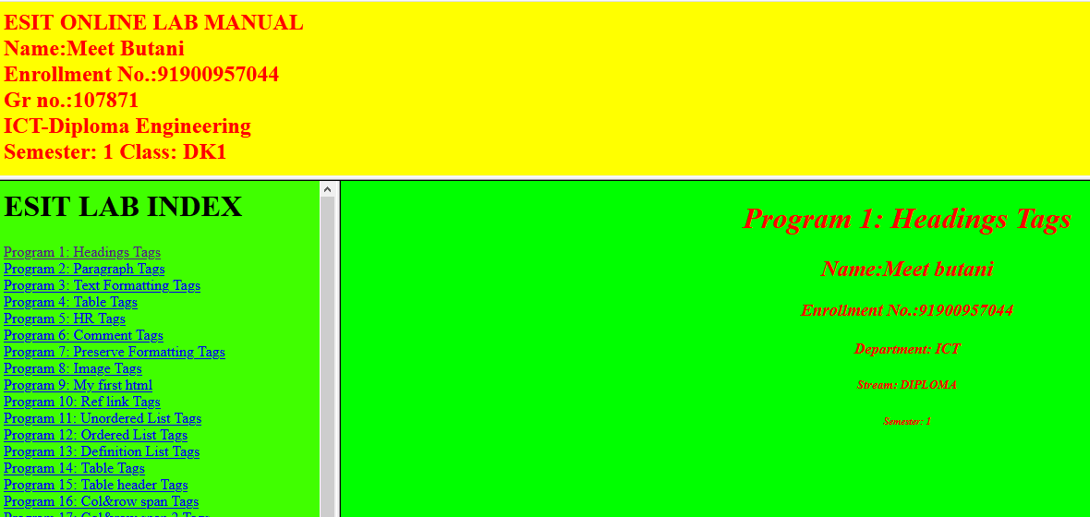

**File Name: Navigation.html**

**Code:**

<html>

<body bgcolor="#40ff00">

<h1> ESIT LAB INDEX</h1>

<a href="A.html" target="showframe"/>Program 1: Headings Tags</a> <br/>

<a href="B.html" target="showframe"/>Program 2: Paragraph Tags</a> <br/>

<a href="C.html" target="showframe"/>Program 3: Text Formatting Tags</a>

<br/>

<a href="D.html" target="showframe"/>Program 4: Table Tags</a>

<br/>

<a href="E.html" target="showframe"/>Program 5: HR Tags</a>

<br/>

<a href="F.html" target="showframe"/>Program 6: Comment Tags</a>

<br/>

<a href="G.html" target="showframe"/>Program 7: Preserve Formatting Tags</a>

<br/>

<a href="H.html" target="showframe"/>Program 8: Image Tags</a>

<br/>

<a href="I.html" target="showframe"/>Program 9: My first html</a>

<br/>

<a href="J.html" target="showframe"/>Program 10: Ref link Tags</a>

<br/>

<a href="K.html" target="showframe"/>Program 11: Unordered List Tags</a>

<br/>

<a href="L.html" target="showframe"/>Program 12: Ordered List Tags</a>

<br/>

<a href="N.html" target="showframe"/>Program 13: Definition List Tags</a>

<br/>

<a href="O.html" target="showframe"/>Program 14: Table Tags</a>

<br/>

<a href="P.html" target="showframe"/>Program 15: Table header Tags</a>

<br/>

<a href="Q.html" target="showframe"/>Program 16: Col&row span Tags</a>

<br/>

</body>

</html>

**Output:**

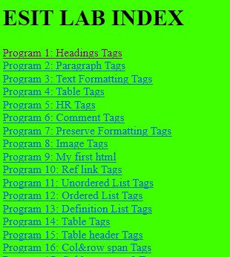

**File Name: Header.html**

**Code:**

<html>

<body bgcolor="yellow" style="color:red">

<h2>ESIT ONLINE LAB MANUAL <br/>

Name:Meet Butani <br/>

Enrollment No.:91900957044<br/>

Gr no.:107871 <br/>

ICT-Diploma Engineering <br/>

Semester: 1 Class: DK1 </h2>

</body>

</html>

**Output:**



**File Name: Heading.html**

**Code:**

<html>

<body bgcolor="#00FF00" text="FF0000" style="text-align:center";>

<i><h1>Program 1: Headings Tags</h1>

<h2>Name:Meet butani </h2>

<h3>Enrollment No.:91900957044</h3>

<h4>Department: ICT</h4>

<h5>Stream: DIPLOMA</h5>

<h6>Semester: 1</h6></i>

</body>

</html>

**Output:**



**File Name:Colspan & Rowspan.html**

**Code:**

<html>

<body bgcolor="darkorchid" style="text-align:center";>

<h4>Cell that spans two columns:</h4>

<table border="2">

<tr>

<th>Name</th>

<th colspan="2">Branch</th>

</tr>

<tr>

<td>MEET BUTANI</td>

<td>ICT</td>

<td>DIPLOMA</td>

</tr>

</table>

<h4>Cell that spans two rows:</h4>

<table border="3">

<tr>

<th>Name</th>

<td>MEET BUTANI</td>

</tr>

<tr>

<th rowspan="2">Branch</th>

<td>ICT</td>

</tr>

<tr>

<td>DIPLOMA</td>

</tr>

</table>

</body>

</html>

**Output:**

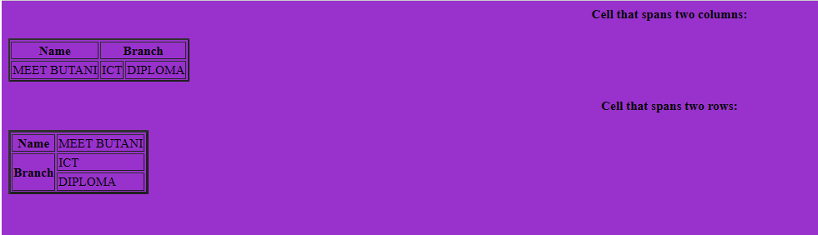

**File Name:Col&Rawframeset.html**

**Code:**

<html>

<frameset rows="50%,50%">

<frame src="mm.html"/>

<frameset cols="50%,50%">

<frame src="nn.html"/>

<frame src="oo.html"/>

</frameset>

</frameset>

<noframes></noframes>

</html>

**Output:**

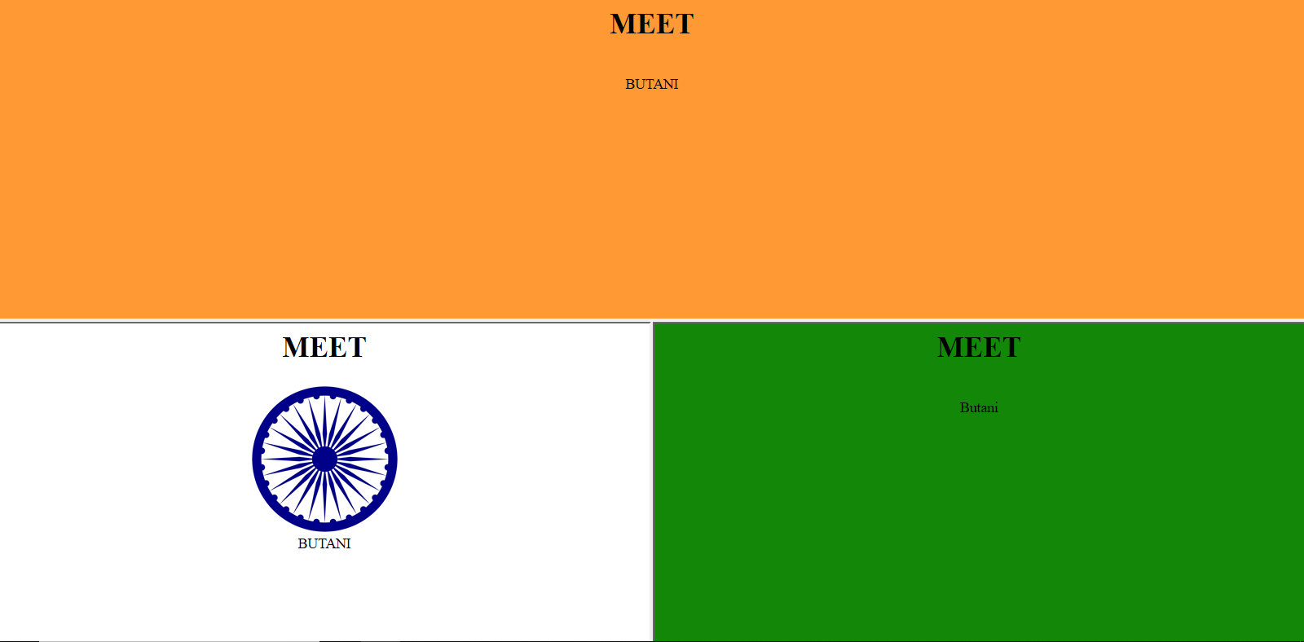

**File Name:Cellspacing and Cellpadding.html**

**Code:**

<html>

<body bgcolor="dodgerblue" style="text-align:center";>

<h4>With cellspacing:</h4>

<table border="5" cellspacing="10" style="text-align:center";>

<tr>

<td>Meet</td>

<td>Butani</td>

</tr>

<tr>

<td>Butani</td>

<td>Meet</td>

</tr>

</table>

<h4>With cellpadding:</h4>

<table border="4" cellpadding="10" style="text-align:center";>

<tr>

<td>Meet</td>

<td>Butani</td>

</tr>

<tr>

<td>Butani</td>

<td>Meet</td>

</tr>

</table>

</body>

</html>

**Output:**

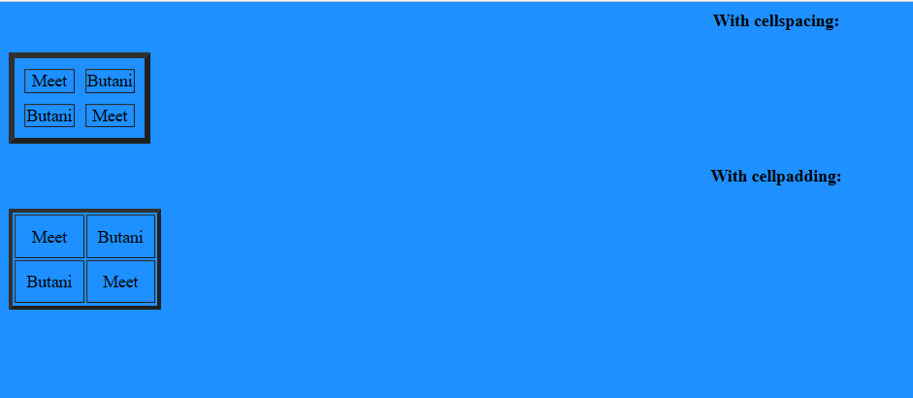

**File Name:Form.html**

**Code:**

<html>

<body bgcolor="#FE840E">

<form action="lab 08.html" method="post">

<fieldset>

<legend>log in now?</legend>

Plese enter your username:<input type="text" value="Meet Butani"/></br>

</br>Enter your password:<input type="password" value="12345678"/></br>

</fieldset>

<fieldset>

<legend>Choices?</legend>

Favourite color:<input type="text" value="Green" /></br>

</br>

My favourite fruit is:

<select>

<option value="apple">apple</option>

<option value="orange">orange</option>

<option value="banana">banana</option>

<option value="mango">mango</option>

<option value="grapes">grapes</option>

</select></br>

</br>

I leave in a:

<input type="radio" name="leave" value="house"/>House

<input type="radio" name="leave" value="flat"/>Flat

<input type="radio" name="leave" value="bedsit"/>Bedsit

<input type="radio" name="leave" value="caravan"/>Caravan</br>

</br>My upload file is:<input type="file">

</fieldset>

<fieldset>

<legend>leaving?</legend>

You can leave a message for me here:<textarea name="address" row="12" column="30">type address</textarea></br>

<input type="submit" name="GO" value="GO"/>

<input type="reset" name="Start Again" value="Start Again"/>

</fieldset>

**Output:**

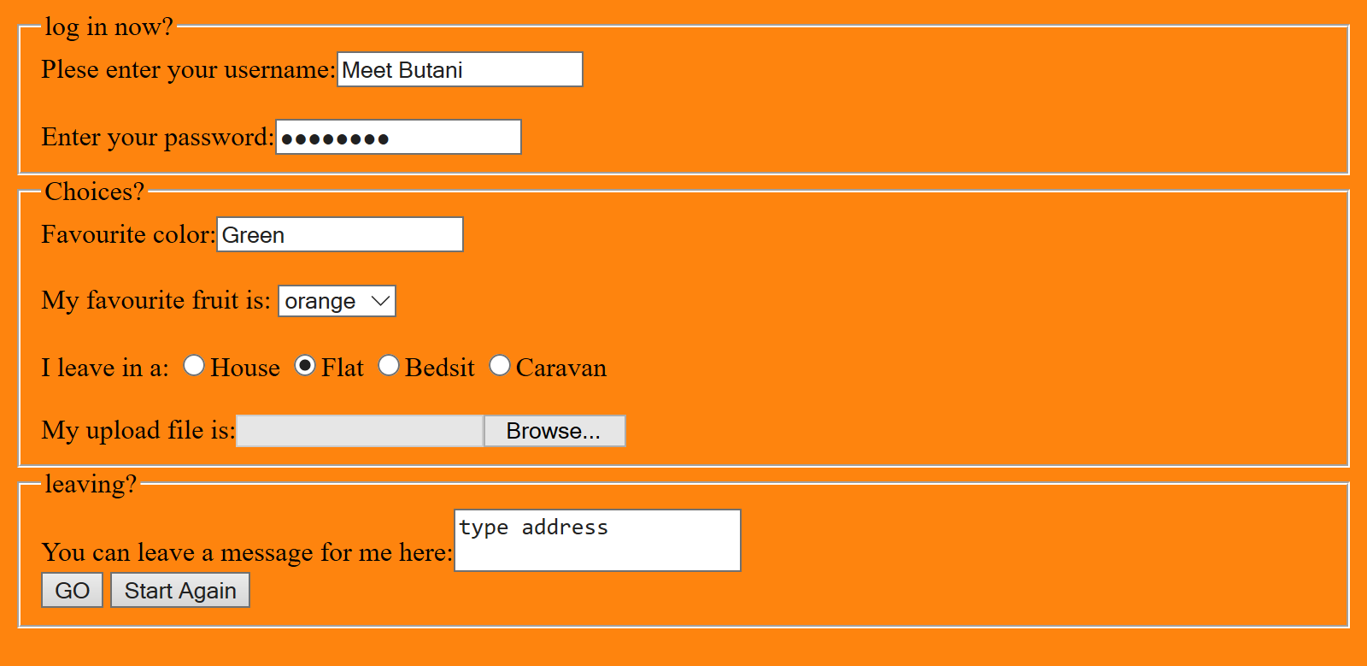

**PRACTICAL 2: CSS**

**File Name:Background.html**

**Code:**

<html>

<body>

<p style="text-align:left; background-image: url('images.png'); background-color:red; color:red; border-style:dotted; border-color:yellow; border-width:5px;">

<br>Enrollment No.:91900957044<br>

<br>Name:Meet butani<br>

<br>Class: DK1<br>

<br>Department: ICT<br>

<br>Course: Diploma Engineering<br>

<br>Semester: 1st<br>

<br></p>

<p style="text-align:center; background-image: url('img_tree.gif'); background-color:green; color:orange; border-style:dashed ; border-color:orange; border-width:4px;";>

<br>Enrollment No.:91900957044<br>

<br>Name:Meet butani<br>

<br>Class: DK1<br>

<br>Department: ICT<br>

<br>Course: Diploma Engineering<br>

<br>Semester: 1st<br>

<br></p>

</body>

</html>

**Output:**

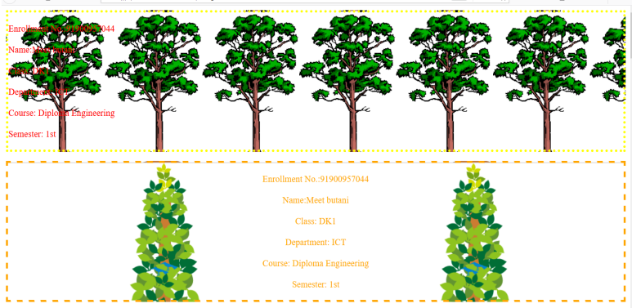

**File Name:Borders.html**

**Code:**

<html>

<body>

<p style="text-align:left; background-color:red; color:yellow; border-style:dotted; border-color:yellow; border-width:5px;">

<br>Enrollment No.:91900957044<br>

<br>Name:Meet butani<br>

<br>Class: DK1<br>

<br>Department: ICT<br>

<br>Course: Diploma Engineering<br>

<br>Semester: 1st<br>

<br></p>

<p style="text-align:center; background-color:green; color:orange; border-style:dashed ; border-color:orange; border-width:4px;";>

<br>Enrollment No.:91900957044<br>

<br>Name:Meet butani<br>

<br>Class: DK1<br>

<br>Department: ICT<br>

<br>Course: Diploma Engineering<br>

<br>Semester: 1st<br>

<br></p>

<p style="text-align:right; background-color:yellow; color:green; border-style:solid; border-color:green; border-width:5px;";>

<br>Enrollment No.:91900957044<br>

<br>Name:Meet butani<br>

<br>Class: DK1<br>

<br>Department: ICT<br>

<br>Course: Diploma Engineering<br>

<br>Semester: 1st<br>

<br></p>

<p style="text-align:center; background-color:blue; color:yellow; border-style:double; border-color: yellow; border-width:4px;";>

<br>Enrollment No.:91900957044<br>

<br>Name:Meet butani<br>

<br>Class: DK1<br>

<br>Department: ICT<br>

<br>Course: Diploma Engineering<br>

<br>Semester: 1st<br>

<br></p>

<p style="text-align:center; background-color:violet; color:golden; border-style:dotted solid dashed double; border-color:golden; border-width:5px;";>

<br>Enrollment No.:91900957044<br>

<br>Name:Meet butani<br>

<br>Class: DK1<br>

<br>Department: ICT<br>

<br>Course: Diploma Engineering<br>

<br>Semester: 1st<br>

<br></p>

</body>

</html>

**Output:**

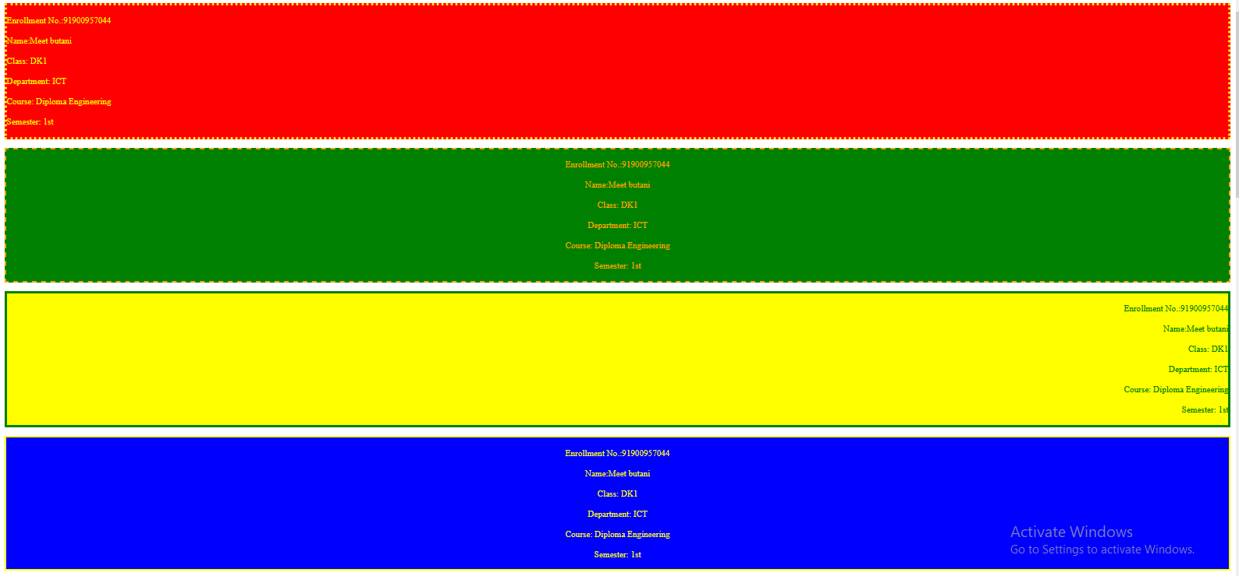

**File Name:Boxmodal.html**

**Code:**

<html>

<body>

<br><p style="border:2px dotted red;margin:20px; padding:6px; outline:10px dashed green ;outline-offset:10px;">

my name is meet .iam study in ICT diploma.my name is meet .iam study in ICT diploma.my name is meet .iam study in ICT diploma.my name is meet .iam study in ICT diploma.my name is meet .iam study in ICT diploma.my name is meet .iam study in ICT diploma.</p><br>

<br><p style="border:3px dashed green;margin:30px; padding-bottom:7px;outline:10px solid yellow ;outline-offset:20px";>

my name is meet .iam study in ICT diploma.my name is meet .iam study in ICT diploma.my name is meet .iam study in ICT diploma.my name is meet .iam study in ICT diploma.my name is meet .iam study in ICT diploma.my name is meet .iam study in ICT diploma.</p><br>

<br><p style="border:2px groove orange;margin:30px; padding:6px;outline:10px ridge red ;outline-offset:10px;";>

my name is meet .iam study in ICT diploma.my name is meet .iam study in ICT diploma.my name is meet .iam study in ICT diploma.my name is meet .iam study in ICT diploma.my name is meet .iam study in ICT diploma.my name is meet .iam study in ICT diploma.</p><br>

<br><p style="border:3px ridge red ;margin:40px; padding-bottom:7px;outline:10px inset green ;outline-offset:20px;";>

my name is meet .iam study in ICT diploma.my name is meet .iam study in ICT diploma.my name is meet .iam study in ICT diploma.my name is meet .iam study in ICT diploma.my name is meet .iam study in ICT diploma.my name is meet .iam study in ICT diploma.</p><br>

<br><p style="border:2px inset green;margin:20px; padding-left:6px;outline:10px outset yellow ;outline-offset:10px;";>

my name is meet .iam study in ICT diploma.my name is meet .iam study in ICT diploma.my name is meet .iam study in ICT diploma.my name is meet .iam study in ICT diploma.my name is meet .iam study in ICT diploma.my name is meet .iam study in ICT diploma.</p><br>

<br><p style="border:3px outset yellow;margin:30px; padding-right:7px;outline:10px none blue ;outline-offset:20px;">

my name is meet .iam study in ICT diploma.my name is meet .iam study in ICT diploma.my name is meet .iam study in ICT diploma.my name is meet .iam study in ICT diploma.my name is meet .iam study in ICT diploma.my name is meet .iam study in ICT diploma.</p><br>

</body>

</html>

**Output:**

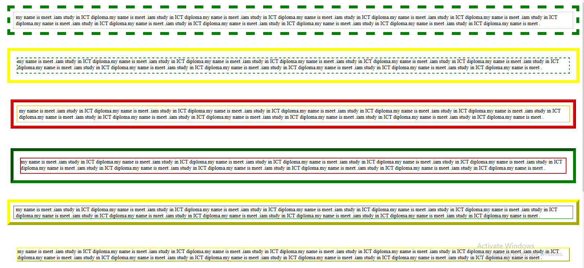

**File Name:Multipal Column.html**

**Code:**

<html>

<head>

<style>

.newspaper {text-align:justify;background-color:#66ff33;color:brown;column-count: 3;column-gap: 60px;column-rule: solid 5px yellow;column-width: 10px;

}

.title{text-align:center;color:red;column-span: all;background-color:yellow;

}

</style>

</head>

<body>

<p class="title" ><b>History Of News Paper</b></p>

<div class="newspaper">

Newspapers began circulating in the 17th century. The first real

newspaper in England was printed in 1665. The first successful

daily newspaper in Britain was printed in 1702. The first

American newspaper was printed in 1690. It was called Publick

Occurrences Both Forreign and Domestick. The first newspaper

in Canada was the Halifax Gazette in 1752. The first daily

American newspaper was published in 1784.

In Britain the first Sunday newspaper was the British Gazette

and Sunday Monitor published in 1780. In 1785 the Daily

Universal Register was first published. In 1788 it was renamed

The Times. In 1814 The Times was printed with a steam-powered

press for the first time. In 1848 The Times used a rotary

printing press with the printing face wrapped around a

cylinder for the first time.

Meanwhile the Observer was founded in 1791. The Daily Telegraph

was first published in 1855. The Manchester Guardian was

founded in 1821. It changed its name to The Guardian in 1959.

The Sunday Times was first published in 1822. The Financial

Times began in 1888. Meanwhile The News Of The World was

published in 1843. Meanwhile the first Australian newspaper

was published in 1803. It was called the Sydney Gazette and

New South Wales Advertiser.

Newspapers became far more common in the late 19th century. In

the 18th century and the early 19th century stamp duty was

charged on newspapers, which made them expensive. However in

1855 stamp duty on newspapers was abolished and they became

cheaper and more common. In the mid-19th century newspaper

reporters began to use the telegraph as a means to get news

to their newspapers quickly. Then in 1880 The New York Graphic

became the first newspaper to print a photo. In Britain the

first tabloid newspaper was the Daily Graphic published in

1890. In 1891 it became the first British newspaper to print

a photo.

</body>

</html>

**Output:**

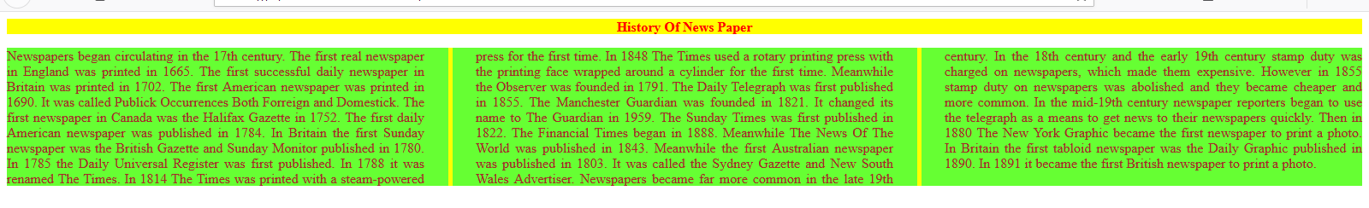

**File Name:Selector.html**

**Code:**

<html>

<head>

<style>

body{background-color:blue}

*{font-family:Ink Free}

div{background-color: #ffff00;}

h1{color:#990000;text-align:right;text-decoration:underline;}

p{color:#5c0099;text-align: center;border:dotted }

span{color: #000099;text-decoration:overline; }

table{border:10px dotted #5c0099;}

th{border:10px ridge blue;color:red}

td{border:10px ridge #9966ff;color:green}

.d1{background-color:#ffff33;}

.h1{color: #cc0000;text-align: right;text-decoration:underline;}

.p1{color: #7a00cc;text-align: center;border:dashed }

.s1{color: #0000cc;text-decoration:overline;}

.t1{border:8px dashed #7a00cc;}

.tr1{border:8px solid blue;}

.th1{border:8px inset blue;}

.th11{border:8px inset #9966ff;}

.tr11{border:8px solid blue;}

.td1{border:8px inset #9966ff;}

.td11{border:8px inset blue;}

#d2{background-color:#ffff66;}

#h2{color: #ff0000;text-align: right;text-decoration:underline;}

#p2{color: #9900ff;text-align: center;border:solid}

#s2{color: #0000ff;text-decoration:overline;}

#t2{border:8px double #9900ff;}

#tr2{border:8px dotted blue;}

#th2{border:8px dotted blue;}

#th22{border:8px dotted #9966ff;}

#tr22{border:8px dotted blue;}

#td2{border:8px dotted #9966ff;}

#td22{border:8px dotted blue;}

div.d3{background-color:#ffff99;}

h4.h3{color: #ff3333;text-align: right;text-decoration:underline;}

p.p3{color: #ad33ff;text-align: center;border:double }

span.s3{color: #3333ff;text-decoration:overline;}

table.t3{border:8px groove #ad33ff;}

tr.tr3{border:8px dashed blue;}

th.th3{border:8px dashed blue;}

th.th33{border:8px dashed #9966ff;}

tr.tr33{border:8px dashed blue;}

td.td3{border:8px dashed #9966ff;}

td.td33{border:8px dashed blue;}

</style>

</head>

<body>

<div>

<h1>heading 1</h1><br>

<p>paragraph 1</p><br>

<span>this is table 1</span><br>

<table align="center"><br>

<tr>

<th>column 1</th>

<th>column 2</th>

</tr>

<tr>

<td>Meet</td>

<td>Butani</td>

</tr>

</table>

</div>

<div class="d1">

<h2 class="h1">heading 2</h2>

<p class="p1">paragraph 1</p>

<span class="s1">this is table 2</span>

<table class="t1">

<tr class="tr1">

<th class="th1">column 1</th>

<th class="th11">column 2</th>

</tr>

<tr class="tr11">

<td class="td1">Meet</td>

<td class="td11">Butani</td>

</tr>

</table>

</div>

<div id="d2">

<h3 id="h2">heading 3</h3>

<p id="p2">paragraph 1</p>

<span id="s2">this is table 3</span>

<table id="t2">

<tr id="tr2">

<th id="th2">column 1</th>

<th id="th22">column 2</th>

</tr>

<tr id="tr22">

<td id="td2">Meet</td>

<td id="td22">Butani</td>

</tr>

</table>

</div>

<div class="d3">

<h4 class="h3">heading 4</h4>

<p class="p3">paragraph 1</p>

<span class="s3">this is table 4</span>

<table class="t3">

<tr class="tr3">

<th class="th3">column 1</th>

<th class="th33">column 2</th>

</tr>

<tr class="tr33">

<td class="td3">Meet</td>

<td class="td33">Butani</td>

</tr>

</table>

</div>

</body>

</html>

**Output:**

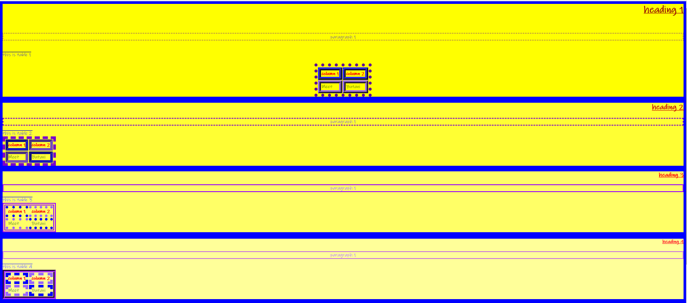

**PRACTICAL 3:JAVASCRIPT**

**File Name:ChangeElement.html**

**Code:**

<!DOCTYPE html>

<html>

<body>

<h2>What Can JavaScript Do?</h2>

<p id="demo">JavaScript can change the style of an HTML element.</p>

<button type="button" onclick="document.getElementById('demo').style.fontSize='20px'">small size</button>

<button type="button" onclick="document.getElementById('demo').style.fontSize='40px'">big size</button>

<button type="button" onclick="document.getElementById('demo').style.display='none'">hide</button>

<button type="button" onclick="document.getElementById('demo').style.display='block'">show</button>

</body>

</html>

**Output:**

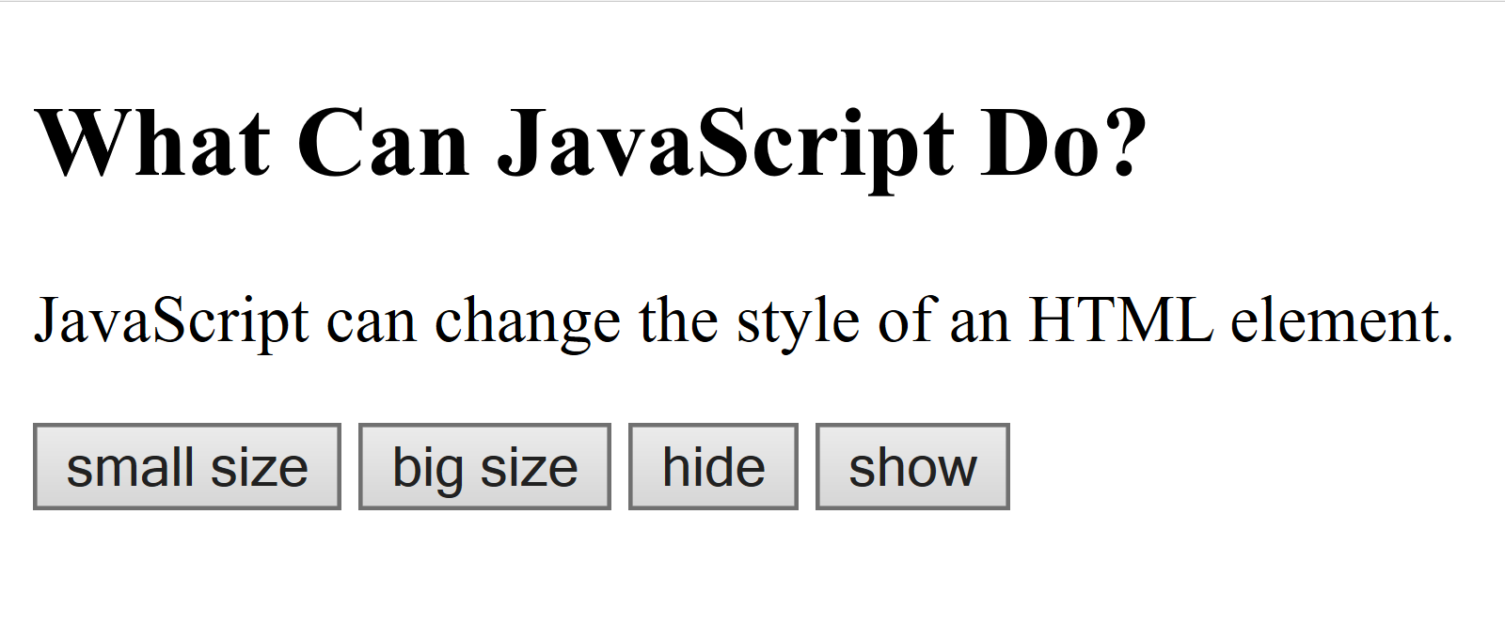

**File Name:TwoNoSum.html**

**Code:**

<!DOCTYPE html>

<html>

<body>

<h2>THE SUM OF 25 + 19</h2>

<p>Solustion</p>

<p id="demo"></p>

<script>

document.getElementById("demo").innerHTML = 25 + 19;

</script>

</body>

</html>

**Output:**

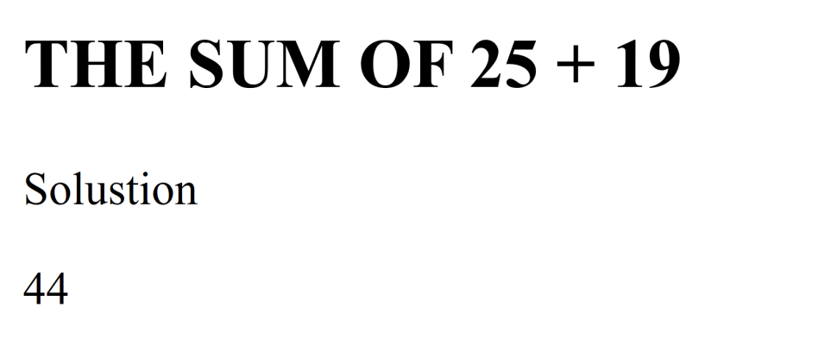

**File Name:DisplayDateAndTime.html**

**Code:**

<!DOCTYPE html>

<html>

<body>

<h2>My First javascript</h2>

<button type="button" onclick="document.getElementById

('demo').innerHTML=Date()">Click me to display Date and

Time</button>

<p id="demo"></p>

</body>

</html>

**Output:**

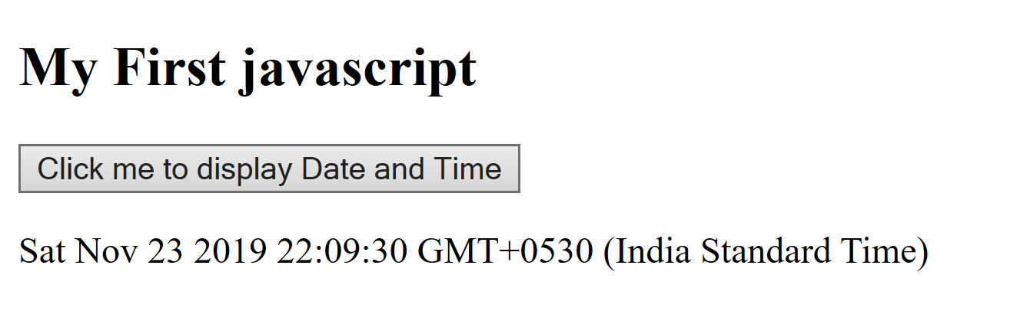

**File Name:Variables.html**

**Code:**

<!DOCTYPE html>

<html>

<body>

<h2>Javascript Variables</h2>

<p id="demo"></p>

<script>

var x="MEET"+" "+"BUTANI";

document.getElementById("demo").innerHTML=x;

</script>

<p>The result of adding 459504780 + 459504790 + "44":</P>

<p id="demo2"></p>

<script>

var x=459504780 + 459504790 + "44";

document.getElementById("demo2").innerHTML=x;

</script>

<p id="demo3"></p>

<script>

var x=22+22;

var y="919009570"+44;

var z="hello"+" "+44;

document.getElementById("demo3").innerHTML=x + "<br>" + y + "<br>" + z;

</script>

</body>

</html>

**Output:**

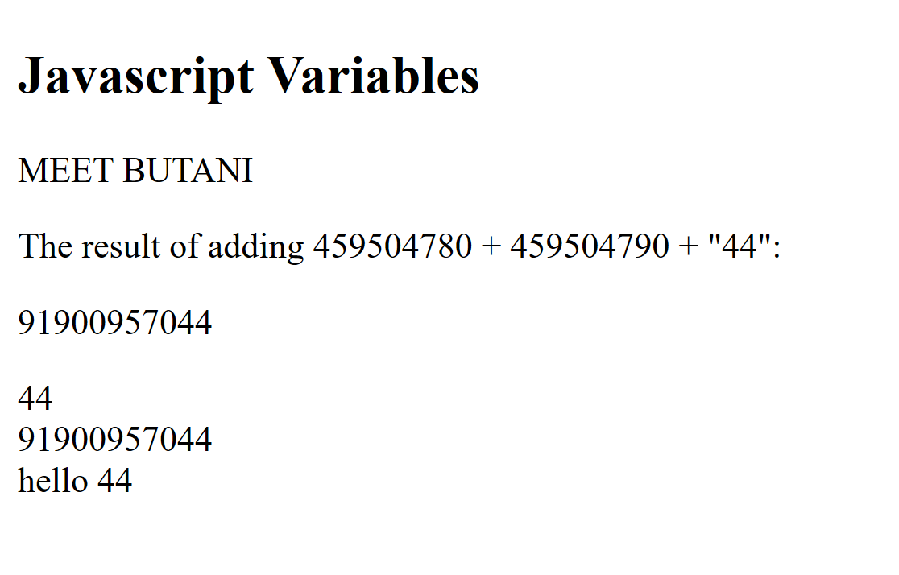

**File Name:Calculator.html**

**Code:**

<!DOCTYPE html>

<html>

<body>

<h2>Javascript Variables</h2>

Number 1: <input type="text" id="m1" name="m1"/>

<br> <br>

Number 2: <input type="text" id="m2" name="m2"/>

<br> <br>

<p id="ans"></p>

<input type="button" value="Addition" onclick="add()"/>

<input type="button" value="Subtraction" onclick="sub()"/>

<input type="button" value="Multiplication" onclick="mul()"/>

<input type="button" value="Division" onclick="div()"/>

<script>

var a, b, result;

function add()

{a=parseInt(document.getElementById("m1").value)

b=parseInt(document.getElementById("m2").value)

result=a + b;

alert(result);}

</script>

<script>

var a, b, result;

function sub()

{a=document.getElementById("m1")

b=document.getElementById("m2")

result=a.value - b.value;

alert(result);}

</script>

<script>

var a, b, result;

function mul()

{a=document.getElementById("m1")

b=document.getElementById("m2")

result=a.value * b.value;

alert(result);}

</script>

<script>

var a, b, result;

function div()

{a=document.getElementById("m1")

b=document.getElementById("m2")

result=a.value / b.value;

alert(result);}

</script>

</body>

</html>

**Output:**

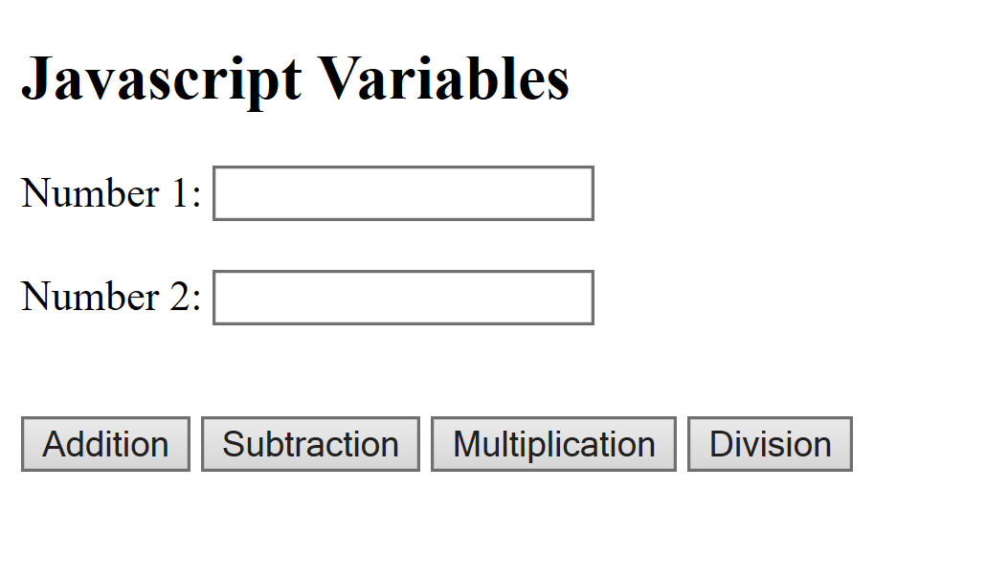

**4. RESULT SPREADSHEET**

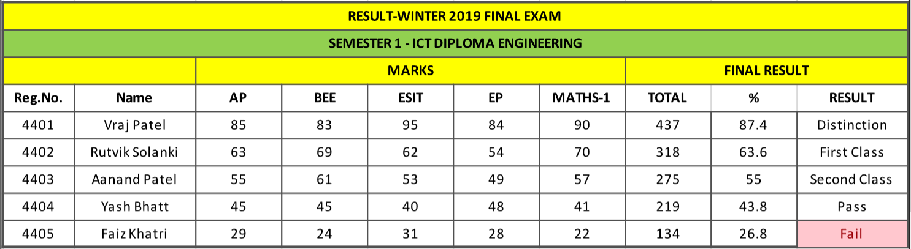

**5. Spoken tutorial Certificate -**

**Introduction to computer**



**6. Solo Learn HTML Certificate**

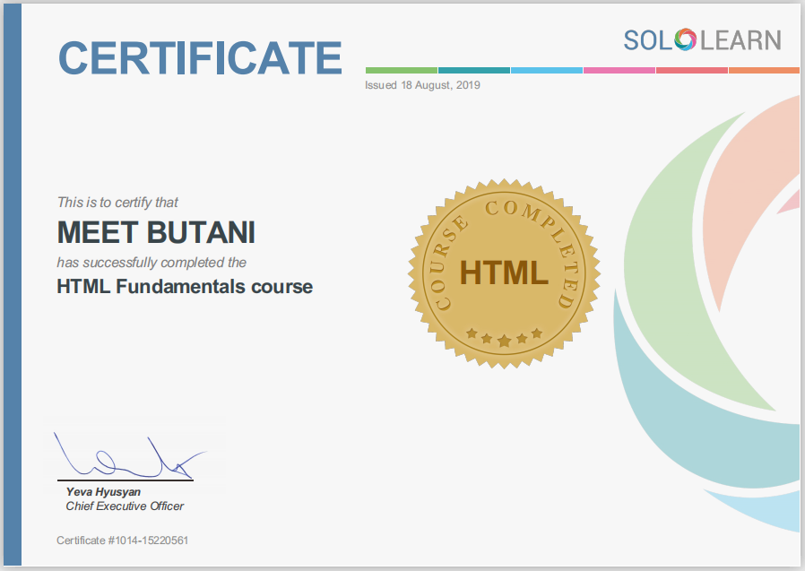

**7. Solo Learn CSS Certificate**

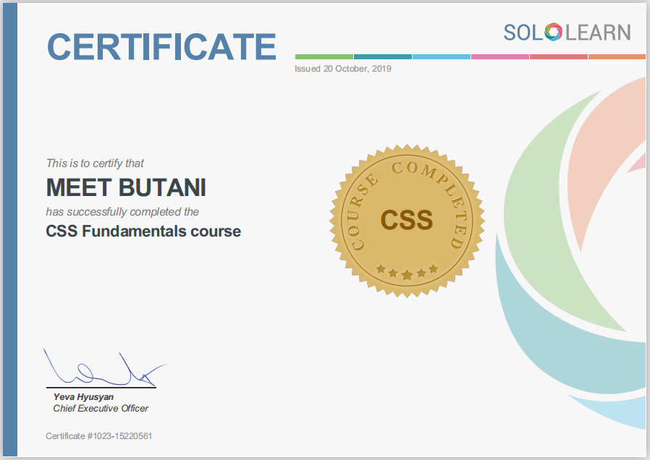

**8. Solo Learn Java Script Certificate**

